Spanikorizo
*Adapted from Michael Psilakis' "How to roast a lamb". Since spelt berries have a lot of great nutrients, I thought they would be a delicious substitution for rice. Turns out, I was right- this was a grand slam!
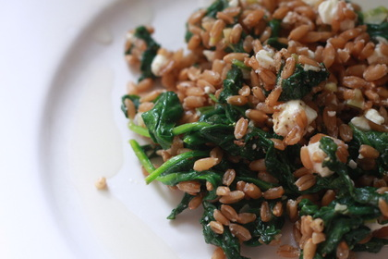
1-2 C spelt berries, soaked overnight (Source: FFM)
fresh spinach
feta cheese
scallions
shallots (if you have 'em, if not, use garlic)
lemon juice
good olive oil
Soak your spelt berries overnight so they dont take as long to cook. Boil soaked spelt berries for about 20-30 minutes in salted water until tender. I cooked mine until they had a little bite left just because I like that sort of texture, but cook them to your liking. Meanwhile, over med-low heat, saute your shallots (or garlic) and scallions briefly. Toss in the fresh spinach and cook until wilted, but still bright green.
Toss drained and still warm spelt berries with the spinach mixture and add feta. Season with fresh squeeze lemon juice and a generous sprinkling of fresh cracked pepper and kosher salt. Serve while still warm.

